8. ReactJS-HOL

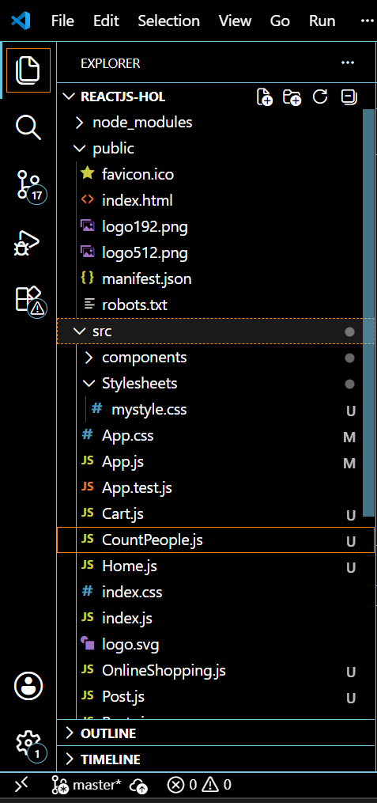

CountPeople.js
import React, { Component } from 'react';
class CountPeople extends Component {
constructor(props) {
super(props);
this.state = {
entryCount: 0,
exitCount: 0
};
}
updateEntry = () => {
this.setState(prevState => ({
entryCount: prevState.entryCount + 1
}));
};
updateExit = () => {
this.setState(prevState => ({
exitCount: prevState.exitCount + 1
}));
};
render() {
return (
<div style={{ textAlign: 'center', padding: '30px' }}>
<h1>🚶‍♂️ Mall People Counter</h1>
<p><strong>People Entered:</strong> {this.state.entryCount}</p>
<p><strong>People Exited:</strong> {this.state.exitCount}</p>
<button onClick={this.updateEntry} style={{ marginRight: '10px' }}>
Login
</button>
<button onClick={this.updateExit}>
Exit
</button>
</div>
);
}
}
export default CountPeople;
App.js
import React from 'react';
import CountPeople from './CountPeople';
function App() {
return (
<div className="App">
<CountPeople />
</div>
);
}
export default App;

OUTPUT:

